Greenhouse Spray Boom Configuration with 22’ hose. The primary advantage with this setup is ease of movement through the cramped research greenhouse setting. Not having a backpack sprayer on the researcher’s back allows easier movement around poles and greenhouse walls, and less cumbersome movement around the research plots.
The 22’ of poly tubing takes approximately 800ml of solution to prime which would need to be included in your overage calculations.
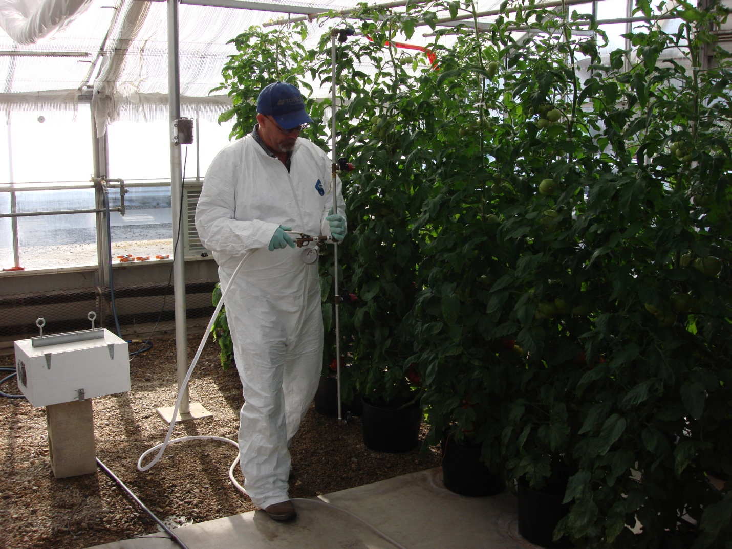
Notice that the boom is essentially a T configuration with a short handle right at the pressure valve. This allows for movement around the poles which support the greenhouse roof.
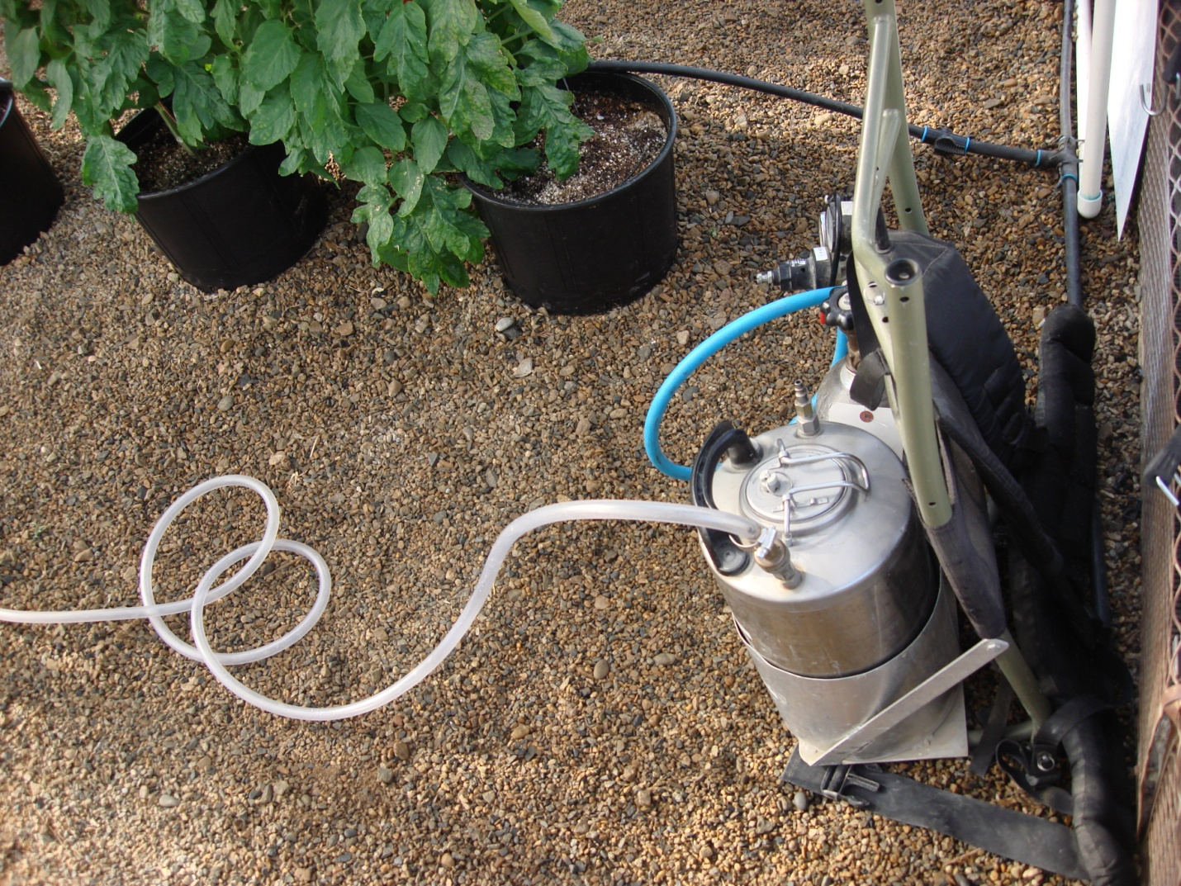
Close up picture of the backpack located on the greenhouse wall with the 22’ poly hose.

