Phone-GPS Permanent marker confirmation
March 1st, 2017, National Education Conference
Rosen Centre Hotel, Orlando, Florida

Background: Smart phones have integrated GPS receivers which are used for determining location for online maps and a variety of GPS applications. A quick demonstration to verify the accuracy of an Android phone's GPS was conducted during a lunch break at the National Education Conference.
Hardware: Stephen's Galaxy 6, Android platform smart phone
Software/App: GPS Essentials (on Google Play, free download)
Procedure:
1) Pick a site which is visible on Google Maps Satellite view:
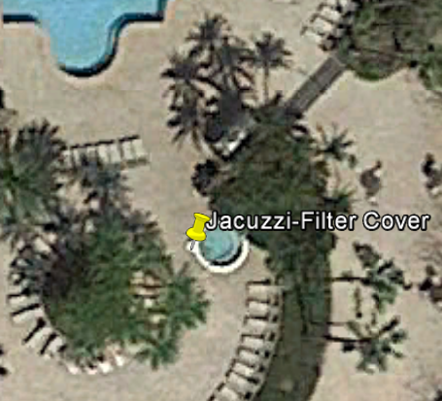
In this example we chose the filter cover on the Jacuzzi on the west side of the Jacuzzi at the Rosen Centre Hotel

2) Use your GPS Application on your smart phone to record a waypoint while you're standing at your known point (in this case the Jacuzzi filter cover).
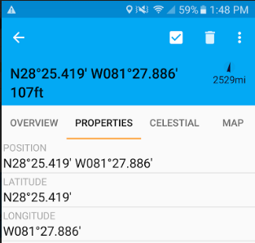
3) Export the Waypoint from your GPS app in KML (Google Maps format) to yourself.
4) Start Google Earth on your desktop & import the KML file, then use the Google Earth ruler application to determine the difference between the known point and your phone's KML waypoint:
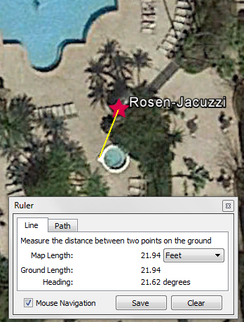
Note: In this example, the Phone GPS app was within 22' of the actual point.
For more information, see the following on the Western Region Website:
http://wrir4.ucdavis.edu/resources/Tricks/default.html
For use in GLP trials your GPS will need to be regularly verified for accuracy. A log recording these verifications can show how close your phone is to a known point over time. Here is an example of an appropriate log:
http://wrir4.ucdavis.edu/resources/Tricks/docs/PM-Log.pdf
