Kearney Research & Education Center Airblast Drift Demonstration
Februrary 2nd, 2010
Parlier, California

Jackie Hale was busy in the background taking a few pictures of our jam-packed training schedule. Here are some shots of the drift demonstration and pictures taken of the spray cards at various lengths downwind from the application.

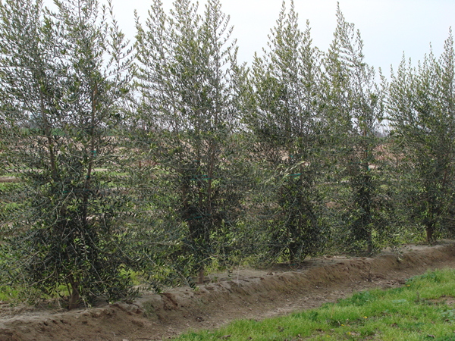Olive Hedgerow Trees

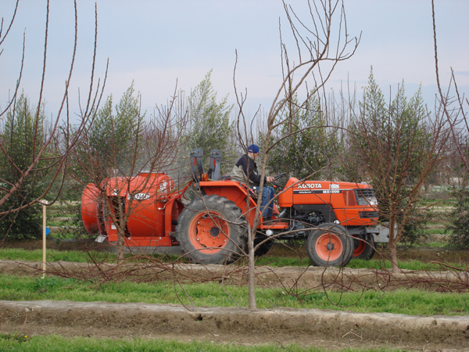
David Ennes Spraying
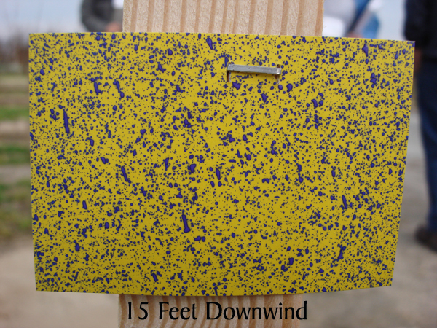
Why 15' buffers for airblast don't work.
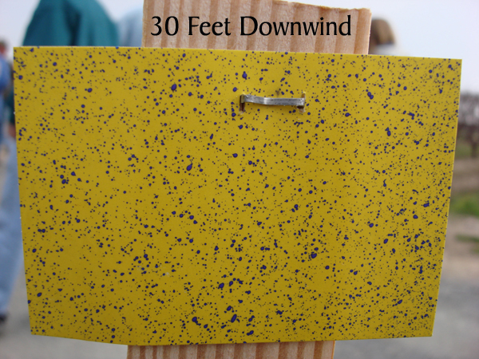
Double the minimum is still not working downwind
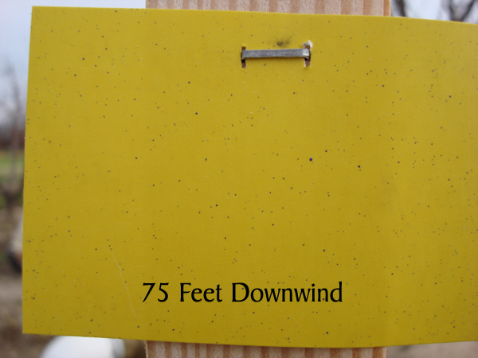
75 Feet still with a significant amount of deposition.
Bottom Line: Small Trees, High Volume, Minimal Buffer Trees, with even a slight breeze would need at least 100' buffers to prevent contamination.

